LAB-10.3
-230351709

Scenario: A junior developer wrote the following Python function to calculate factorials:
Prompt used: # Debug the factorial function , fix the bug, compare with AI's correction. take user input for testing the function.give incorrect code and by using ai assistang give another correct version of code

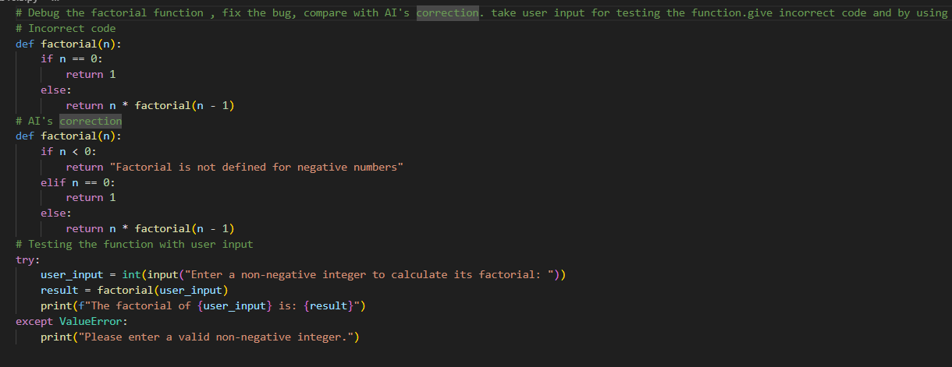
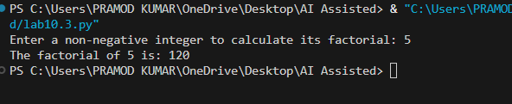

Scenario:The following code works but is poorly written:
def calc(a, b, c):
if c == "add":
return a + b
elif c == "sub":
return a - b
elif c == "mul":
return a * b
elif c == "div":
prompt used: # Fix the calc() function: use clear names, add comments, handle errors, then test it with good and bad inputs. take as user input
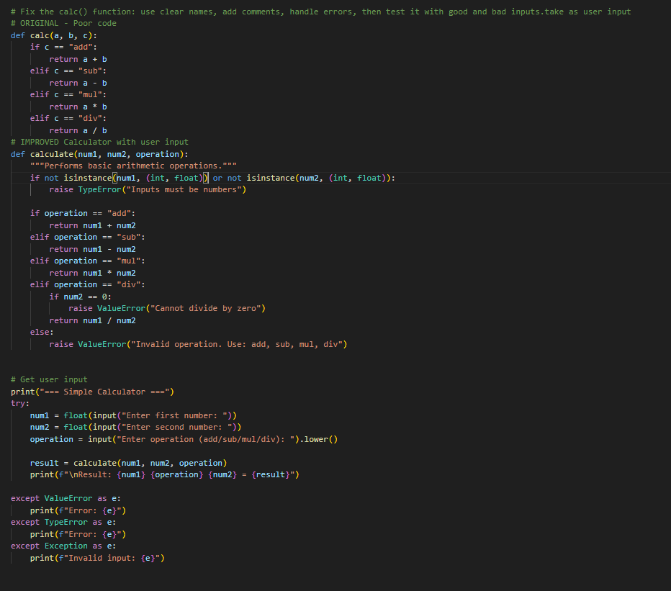
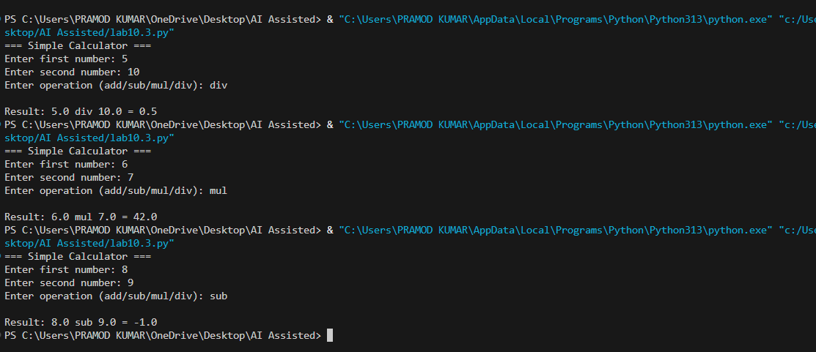

Scenario: A team project requires PEP8 compliance. A developer submits:
def Checkprime(n):
for i in range(2, n):
if n % i == 0:
return False
return True
prompt used: # Check this Python code for PEP8 errors, fix the naming, spacing, and indentation to make it PEP8-compliant, test it with sample inputs, and briefly explain how AI tools help in code reviews. take user input values
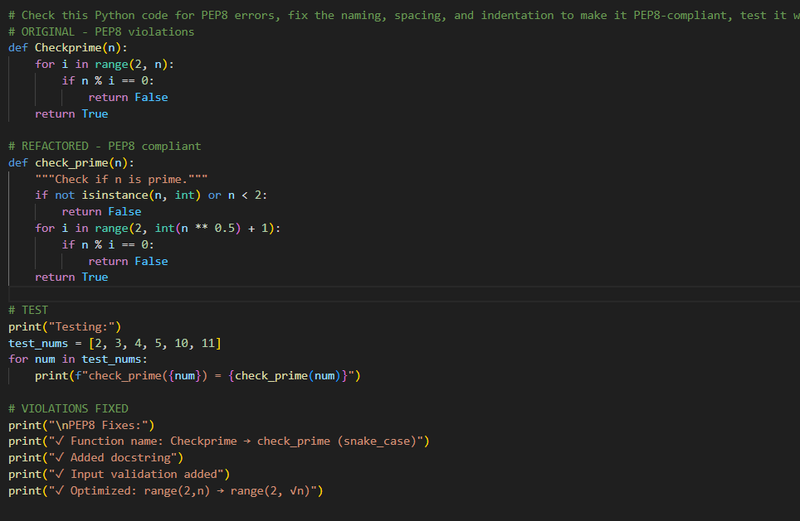

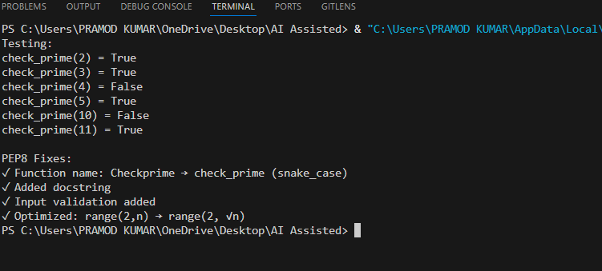

Scenario: In a GitHub project, a teammate submits:
def processData(d):
return [x * 2 for x in d if x % 2 == 0]
prompt used: # "Review this Python function, improve naming and readability, add type hints and input validation, allow a custom multiplier, handle edge cases, and refactor the code."
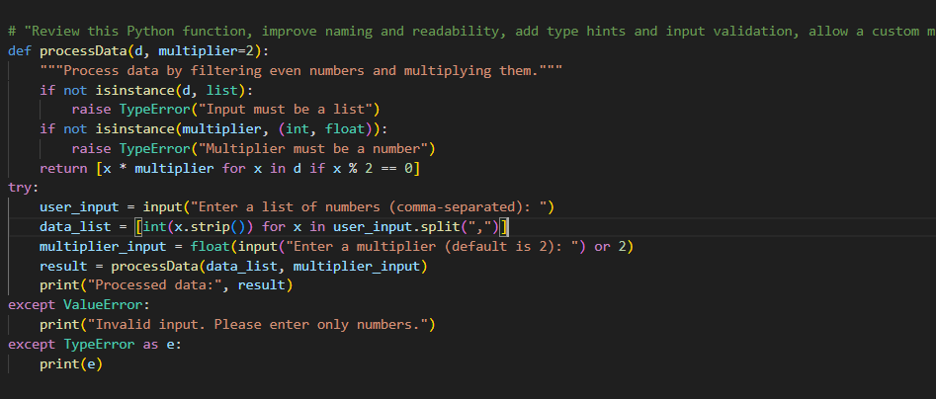
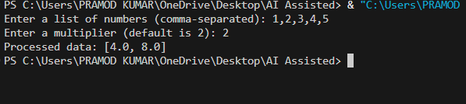

Scenario: You are given a function that processes a list of integers, but it runs slowly on large datasets:
def sum_of_squares(numbers):
total = 0
for num in numbers:
total += num ** 2
return total
prompt used: # Analyze this Python function for time complexity, optimize it for large lists using built-in functions, and compare performance.
